Chapter 01: Introduction to Management and Organizations

Table of Contents

Types of Managers 2

Efficiency and Effectiveness 3

Roles of Managers 4

Management Skills 5

Organizations 6

Types of Organizations 6

Brian Scudamore is the CEO of a famous garbage collection company called 1-800-GOT-JUNK. He revolutionized the management sector by introducing the mind-blowing concept of allowing managers who worked under him to disagree with him.

**Managers** have mainly four **functions**: planning, organization, leading and controlling. They provide instructions on what to do and how to do it.

There have been several research works on the need for good management:

1. Gallup Organization – A big survey concluded that the productivity and loyalty of employees depends on their relationship with their direct supervisors.
2. KPMG/IPSOS-Reid – This survey concluded that good managers lead to the best long-term investment.
3. Watson Wyatt – The survey found that the way employees are managed significantly affects the financial performance of the company.

## Types of Managers

1. **Low-Level**

These managers are directly or indirectly involved with the production of products or services of the company. These include shift managers, district managers, etc.

1. **Mid-Level**

These managers manage multiple projects and work above the low-level managers. They include department managers and floor managers.

1. **Top-Level**

These are the CEOs and Presidents. They manage the business strategies.

## Efficiency and Effectiveness

The job of a manager is to complete projects **effectively** and **efficiently**. To be effective is to be right and to be efficient is to produce the maximum output possible from limited input.

The chart below compares the efficiency and effectiveness in terms of a student group working on a project:

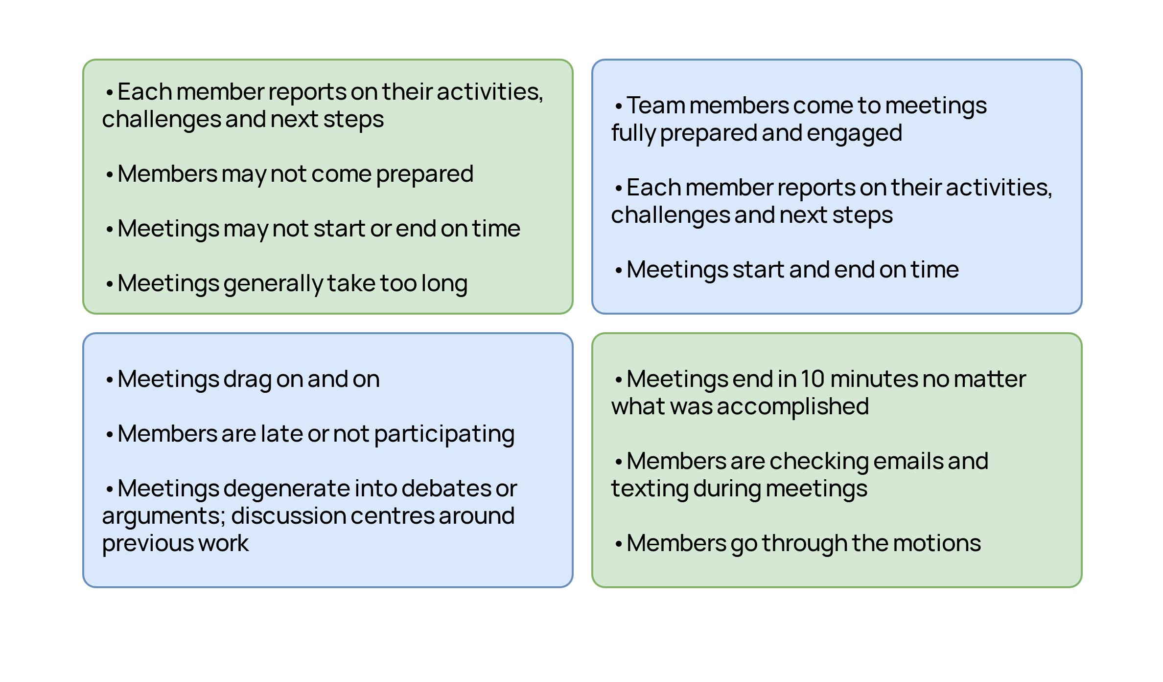

## Roles of Managers

Managers have a total of 10 roles spread across three categories: interpersonal, informational and decisional.

|  |  |  |
| --- | --- | --- |
| **Role** | **Description** | **Examples of Identifiable Activities** |
| **Interpersonal** | | |
| Figurehead | Symbolic head; obliged to perform a number of routine duties of a legal or social nature | Greeting visitors; signing legal documents |
| Leader | Responsible for the motivation of subordinates; responsible for staffing, training, and associated duties | Performing virtually all activities that involve subordinates |
| Liaison | Maintains self-developed network of outside contacts and informers who provide favours and information | Acknowledging mail; doing external board work; performing other activities that involve outsiders |
| **Informational** | | |
| Monitor | Seeks and receives a wide variety of internal and external information to develop a thorough understanding of organization and environment | Reading periodicals and reports; maintaining personal contacts |
| Disseminator | Transmits information received from outsiders or from subordinates to members of the organization | Holding informational meetings; making phone calls to relay information |
| Spokesperson | Transmits information to outsiders on organization’s plans, policies, actions, results, etc. | Holding board meetings; giving information to the media |
| **Decisional** | | |
| Entrepreneur | Searches organization and its environment for opportunities and initiates “improvement projects” to bring about changes | Organizing strategy and review sessions to develop new programs |
| Disturbance handler | Responsible for corrective action when organization faces important, unexpected disturbances | Organizing strategy and review sessions that involve disturbances and crises |
| Resource allocator | Responsible for the allocation of organizational resources of all kinds—making or approving all significant organizational decisions | Scheduling; requesting authorization; performing any activity that involves budgeting and the programming of subordinates’ work |
| Negotiator | Responsible for representing the organization at major negotiations | Participating in union contract negotiations |

## Management Skills

There are three types of management skills:

1. **Technical Skills** – Knowledge about the technicalities of production is required at lower levels.
2. **Human Skills** – Charisma is important at the mid-level, since these managers communicate between the lower level, who usually only understand the technicalities, and the higher level, who usually only understand how to do business.
3. **Conceptual Skills** – At the higher levels, conceptual skills are important to be able to take business decisions.

## Organizations

To be an **organization**, there are a few requirements:

1. Have a **distinct purpose**.
2. Have a **group of people**.
3. Have a **deliberate structure**.

Organizations can be small or large. A large organization is any organization with more than 100 people involved.

### Types of Organizations

1. **Publicly Held Private Organizations**

These are organizations that have shares in the share market. There is a board of directors to whom managers report.

1. **Privately Held Organizations**

These organizations have no shares in the share market. They are usually controlled by one person or family.

1. **Non-Profit Organizations**

These organizations provide charitable services and are not revolved around making a profit.

1. **Crown Corporations**

These are structured like the private sector in that they have a board of directors and may even have shares in the share market. However, these organizations are owned by the government. Managers working in these organizations tend to have easier jobs since they have no accountability.